**Q4. Build an HTML page with multiple paragraphs, each assigned a unique class name. Write CSS rules using class selectors to apply distinct styling to each paragraph. Follow the BEM naming convention and explain how you've named the classes.**

BEM - Block, Element, Modifier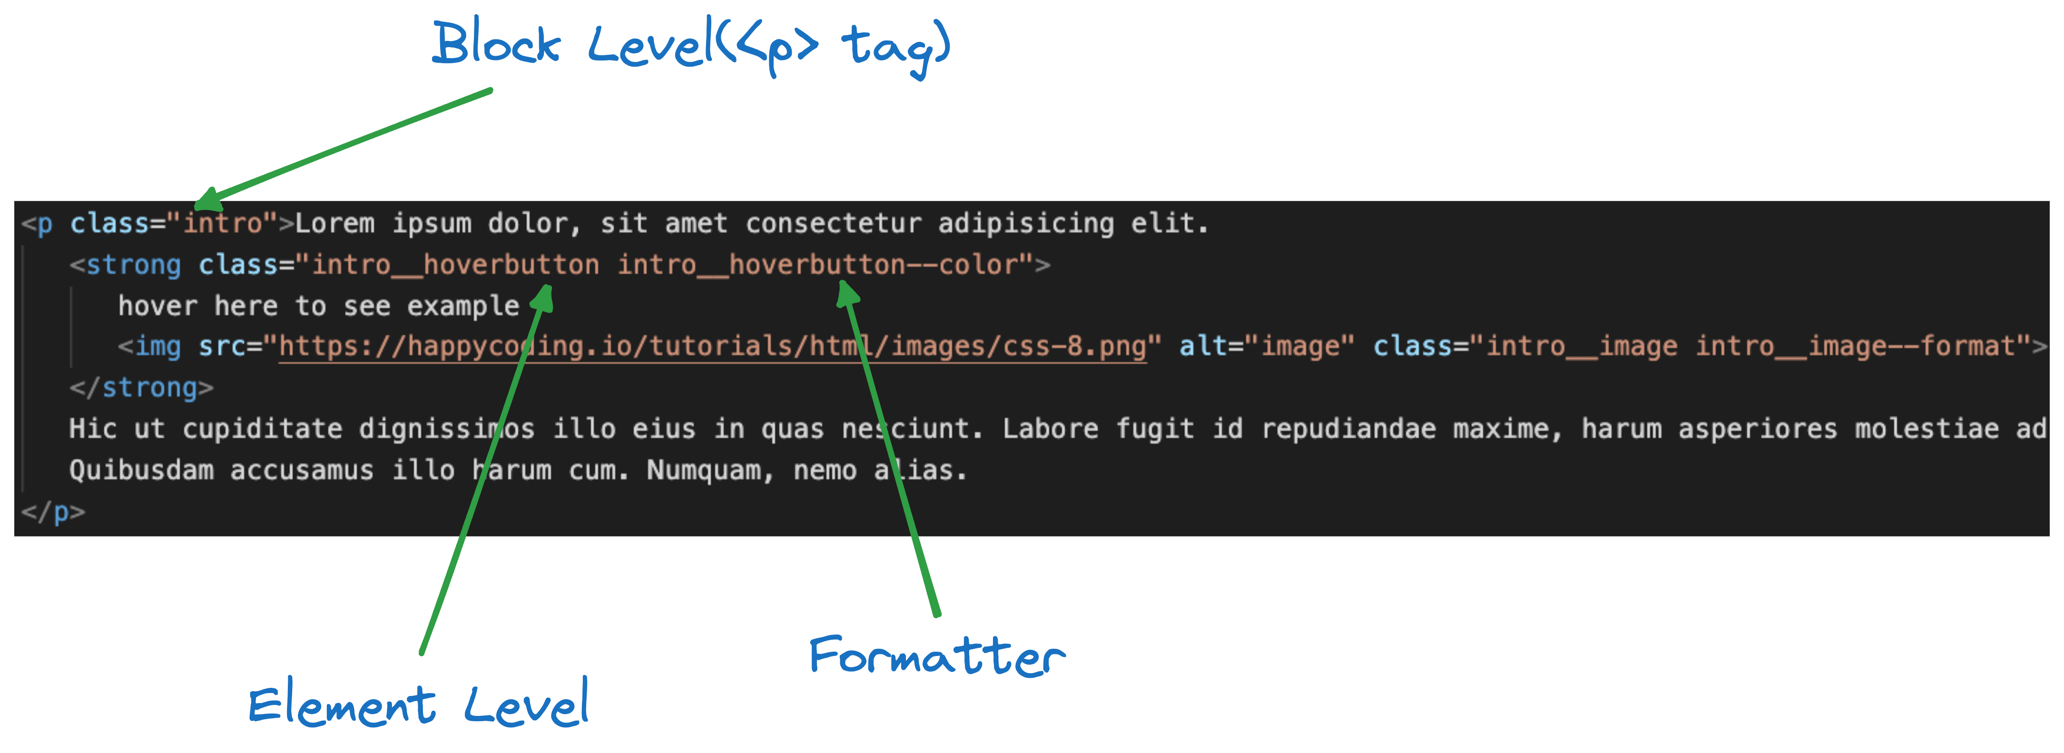

* Here I have created a paragraph with one child and grand-child in it.
* Here it has class based on BEM convention.
* Block level is called **“intro”** because it gives introduction of the page.
* **“intro__hoverbutton”** is a child of “intro” whenever mouse is hovered on it image is displayed.
* **“intro__hoverbutton—color”** is a formatter used to style the **“intro__hoverbutton”.**
* **“intro__image”** and **“intro__image—format”** are the classes for image to modify and style the images.